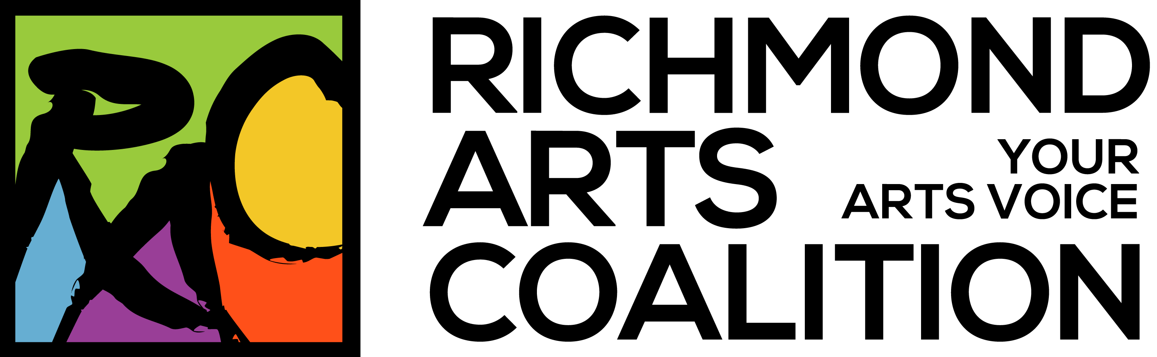
www.richmondartscoalition.com
Our mission:
To promote, support and advocate for the Arts in all their various forms within Richmond, BC.
Arts disciplines we support:
visual, theatre, performance, public, new media, photography, literary, culinary...
Our members:
artists, arts & culture organizations, and community supporters of the Arts.

Richmond Arts Coalition Membership Application Form
列治文藝術聯盟個人會員申請表格

Yes, we would like to join the Richmond Arts Coalition! (Please print clearly)
是的，我們需要您加入列治文列治文藝術聯盟 （請注意字跡清楚）

Name 英文姓名 ______________________________
Address 英文地址 ______________________________
City 城市 _________________________ Postal Code 郵編 _______________
Phone 電話 _________________________
Email 電子郵件 ___________________________________
I am: 􀀀 an artist in this discipline 我是 一名藝術家，在這一領域 _______________________
􀀀 a member of this arts, cultural or heritage organization
藝術文化或者文化遺產機構的成員 (機構英文名） ________________________
􀀀 a community supporter of the Arts 藝術方面的社區支持者

Type of membership 會員種類:
􀀀 Ten year membership 十年會員 $80
􀀀 Five year membership 五年會員 $45
􀀀 Regular annual membership 一年會員 $10 (however, we recommend one of the other 2 options 我們建議選擇上面兩種會員)
Payment to Richmond Arts Coalition accepted by 付款方式:
􀀀 cheque 支票 􀀀 cash 現金
􀀀 Interac e-transfer 電子郵件匯款 (by emailing the link, sender name, amount, description and password to 請將連接、姓名、金額、描述以及密碼發至
treasurer@richmondartscoalition.com)
Mail registration form and payment to 郵寄申請表或支票至:
Richmond Arts Coalition
6500 Gilbert Rd.
Richmond, BC
V7C 3V4
Or email to 或者電子郵件至 rac@richmondartscoalition.com

